Assignment 1
High-End-Devices
Karthik Ganta -002647311

I have connect my pi over the IP 10.159.87.7

Screenshot for the ifconfig:

Question 1: Provide the output of ifconfig, rustc –version, sudo apt list –installed.
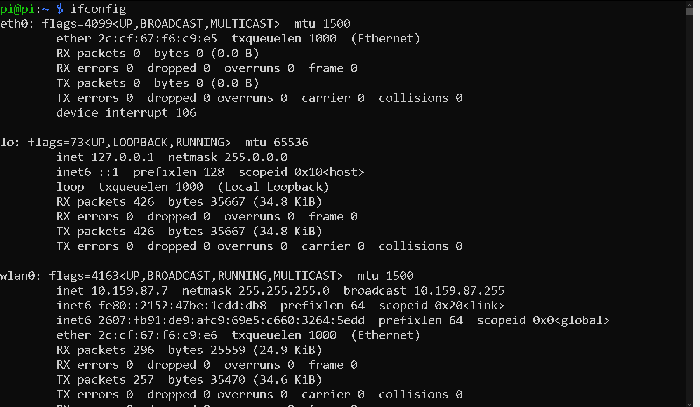

Rust Version:

Rust Installation:
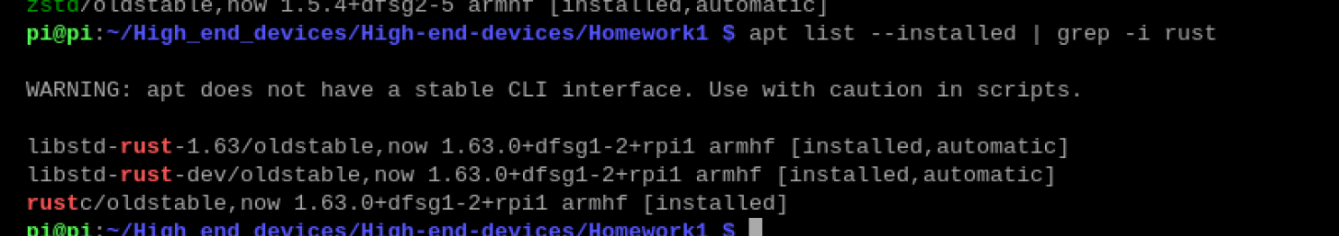

Question 2: Write a rust progr
am that allocates six static variables (unsigned 8-bit A, unsigned
16-bit B, unsigned 32-bit C, unsigned 64-bit D, unsigned 128-bit E, unsigned 8-bit F) and
six local variables (unsigned 8-bit a, unsigned 16-bit b, unsigned 32-bit c, unsigned 64-bit
d, unsigned 128-bit e, unsigned 8-bit). Print out the addresses of these variables. Show the
output. Draw conclusions.

The below screenshot provides the code of the Rust program

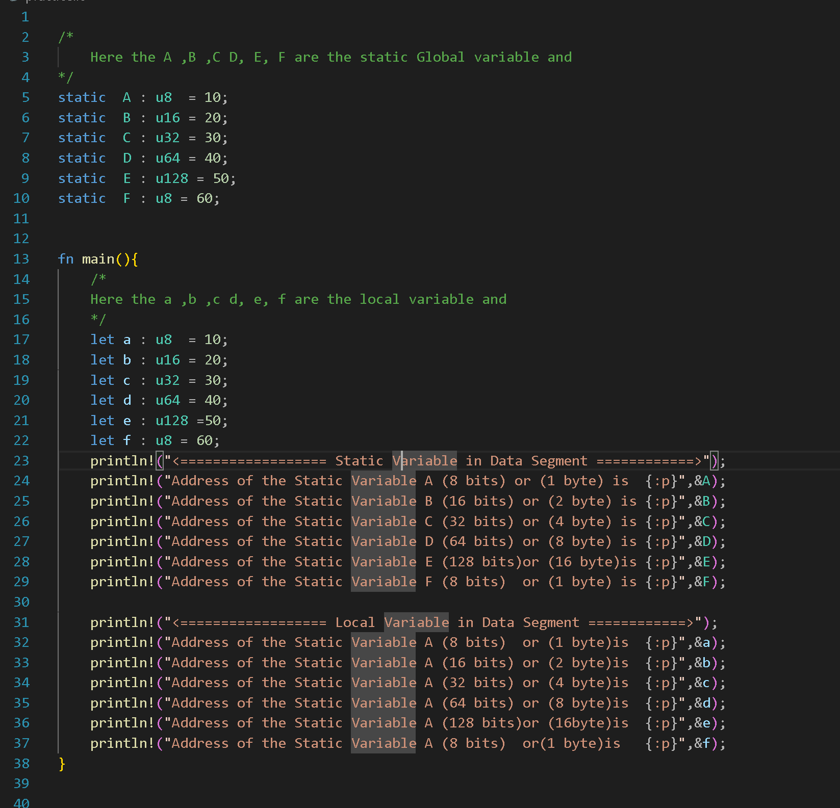

As mentioned in the comment line’s ABCDEF are the global variables and the abcdef variable’s are the local variable

Output:
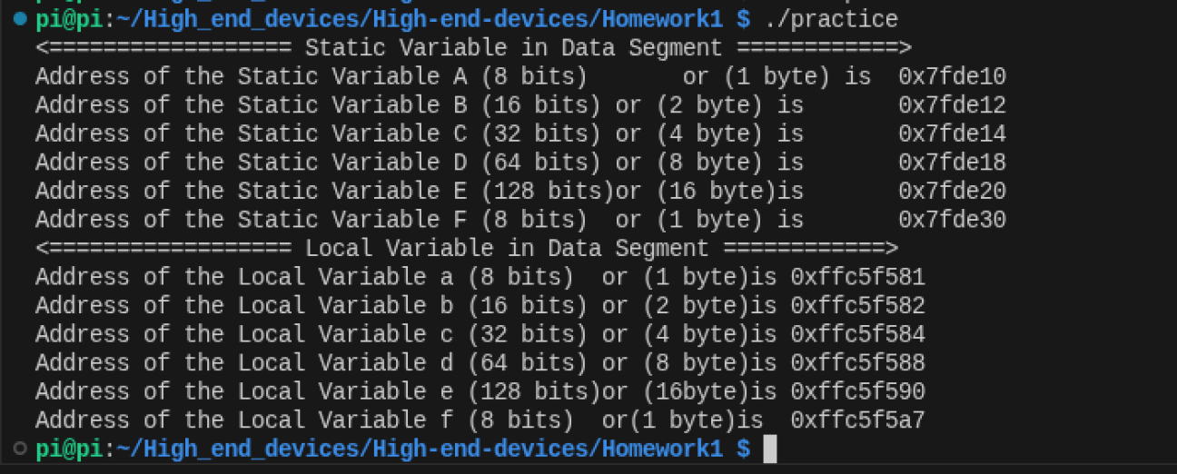

Now the conclusion from the output:
Observation 1: We can see that the variable A which is static global variable with the memory location 0x7fde10in the Data Section
Observation 2: We can see that the variable a which is Local variable with the memory location 0xffc5f581 in the Stack Segment .

Observation 3: Both in the stack section and the Data Section the memory location are byte aligned
for example :

Static Variable A u8 (1 byte ) with memory location 0x7fde10 and Static Variable B (2 byte) is 0x7fde12 so the Variable A is occupies 1 byte of space

For Static Variable :
Static Variable A occupies ==> (1 byte) with memory 0x7fde10

Static Variable B occupies ==> (2 byte) with memory 0x7fde12 to 0x7fde14

Static Variable C Occcupies (4 bytes) => with memory 0x7fde14 to 0x7fde18

Static Variable D Occcupies (8 bytes) => with memory 0x7fde18 to 0x7fde20

Static Variable E Occcupies (16 bytes) => with memory 0x7fde20 to 0x7fde30

Static Variable F Occcupies (1 bytes) => with memory 0x7fde30

For Local Variable :

Local Variable a occupies ==> (1 byte) with memory 0xffc5f581

Local Variable B occupies ==> (2 byte) with memory 0xffc5f582 to 0xffc5f584

Static Variable C Occcupies (4 bytes) => with memory 0xffc5f584 to 0xffc5f588

Static Variable D Occcupies (8 bytes) => with memory 0xffc5f588 to 0xffc5f590

Static Variable E Occcupies (16 bytes) => with memory 0xffc5f590 to 0xffc5f5a7

Static Variable F Occcupies (1 bytes) => with memory 0xffc5f5a7

Observation 4: Stack Always grows in the downward Direaction.

